Introduction 1
Where to download 1
Objectives 1
Key concepts, interfaces, and classes 2
Step-by-step how to 3

Introduction
This document details the concepts used in the AndroMDA.ScenarioUnit testing framework and how to use and extend its current features.

Where to download
The source code and binary releases for this framework can be downloaded from the following URL:
http://sourceforge.net/project/showfiles.php?group_id=154568

Objectives
AndroMDA.ScenarioUnit is written with the following objectives in mind:
- Separate test data and test code and enable Data-Driven Testing through the use of data providers. Usually, a system under test needs to be tested for several scenarios. E.g. given a method int Add(int a, int b), you will want to have probably the following tests:
  - Add(1, 2) – valid test
  - Add(0, 0) – border condition
  - Add(-1, 1) – business rule may say that this throws invalid input exception
  - Add([very large number], [very large number]) -- may throw an exception or just truncate the result.
In the above example, we want to call the same function over and over with different sets of data.
This framework introduces the concept of “Data providers” that allow you to separate test code (call to the Add() method) and test data providing greater reuse and readability.
Data providers can pull out the required data from multiple sources, such as XML files, Excel files or helper code methods. The test code however, remains independent from the way this data is stored.

- Provide more Test completeness through the use of automatic asserters. The results returned from calling the system under test in a test case need to be verified by performing assertions against expected data. While writing plain NUnits, this is the most tedious task specially when dealing with large objects. Developers usually do not assert the entire object and use simple tests like checking one or two key properties, checking for not null or asserting the number of objects returned is greater than 0.
This framework introduces the concept of a configurable asserter that can be given an expected output and the actual output and it will automatically do the asserts. The framework currently has an XML-based asserter implemented.

- This framework tries to extend NUnit and other existing testing frameworks without trying to re-invent the wheel.

- The framework also ensures that traditional NUnits can still be written along side the tests that use this framework.

Key concepts, interfaces, and classes
The following diagram contains the key classes that form a part of this framework.

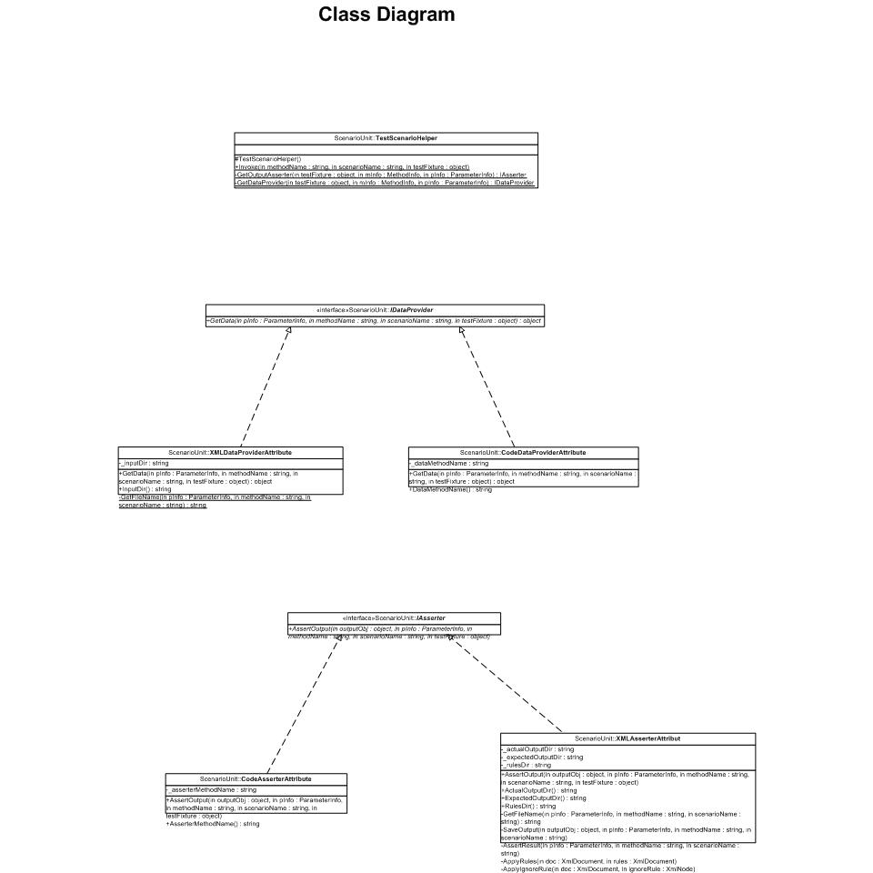
- TestCase: The framework uses the existing notion of a TestCase as used in NUnit. Each TestCase executes one test scenario on the system under test. All the test cases testing the same functionality depend on a common helper method, referred to as a “Test Method” in the remainder of this document.

- TestScenarioHelper: This is a helper class in the framework that is called by a TestCase to invoke a Test Method. The responsibilities of this helper class include:
  - Pass in the input data required to call the system under test for a specific “named” scenario by using a configured concrete IDataProvider implementation.
  - Compare the actual output returned by the system under test with the expected output for the specific “named” scenario by using a concrete IAsserter implementation.

The following diagram illustrates the sequence in which the whole testing cycle takes place.

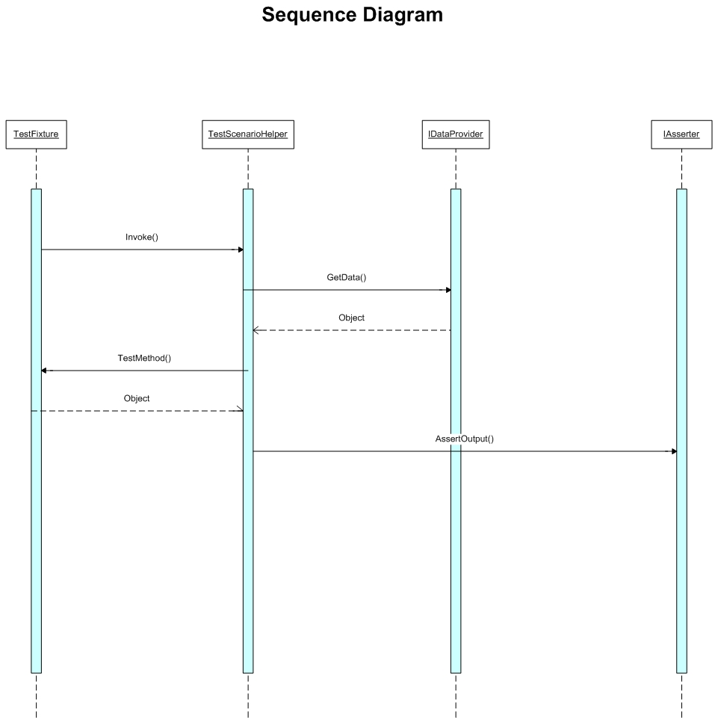
The “Step-by-step how to” section further helps clarify this sequence.

- IDataProvider: This is the interface that is implemented by all concrete Data providers. The following 2 data providers are implemented:
  - XMLDataProvider: reads input from an XML file.
  - CodeDataProvider: Reads input from a helper method (similar to the traditional mechanism of segregating test data from code.)

    - IAsserter: This is the interface that is implemented by all concrete asserters. An asserter takes actual and expected output and performs asserts on the two. This can potentially help to reduce the effort required to assert large objects. The following 2 asserters are implemented:
        - XMLAsserter: This asserter uses objects serialized as XML to compare expected and actual output. The benefits of using this asserter include: very little or no effort required to write assertion logic in test cases and the ability to ignore the assertion of specific fields e.g. dynamic fields like “lastUpdateTime” that cannot be specified in the expected output.
One limitation is that this asserter can be used only for objects that can be serialized into XML.

        - CodeAsserter: This is a concrete implementation of IAsserter that uses a helper method to perform the assertion logic. This is almost like the traditional mechanism of performing all the asserts manually and is implemented to show-case the extensibility of the framework.

Extensibility: To extend the framework to use other data sources, such as Excel or a database, simply implement the IDataProvider interface. The concrete implementation will need to be implemented as a .net attribute so that it can be configured for test cases (See the XMLDataProvider and CodeDataProvider implementations for an example.)
Similarly, you can implement the IAsserter interface to create your own asserter.

Step-by-step how to
This section details the steps required to set up AndroMDA.ScenarioUnit for a test project. These steps assume that we are writing unit tests for the following class:
Public class MoneyService{
Public static Money Add(Money m1, Money m2){//implementation…}
}

Public class Money {
Public int amount;
Public string currency;
}

A traditional NUnit TestFixture to test the above code looks like:
[TestFixture]
Public class TestMoneyService
{
[TestCase]
public void testSimpleAdd() {
Money m12CHF= new Money(12, "CHF");
Money m14CHF= new Money(14, "CHF");
Money expected= new Money(26, "CHF");
Money result= MoneyService.Add(m12CHF, m14CHF);
Assert.AreEqual(expected.amount, result.amount);
Assert.AreEqual(expected.currency, result.currency);
}

[TestCase]
public void testMultipleCurrencyAdd() {
Money m12CHF= new Money(12, "CHF");
Money m14USD = new Money(14, "USD");
Money expected= new Money(46, "CHF"); //based on some conversion rate between USD and CHF.
Money result= MoneyService.Add(m12CHF, m14USD);
Assert.AreEqual(expected.amount, result.amount);
Assert.AreEqual(expected.currency, result.currency);
}

}

The above test fixture tests 2 scenarios, “SimpleAdd” and “MultipleCurrencyAdd”, for the MoneyService.Add() method. The following steps cover how to write the same tests using AndroMDA.ScenarioUnit.
- Download the latest version of AndroMDA.ScenarioUnit.dll from http://sourceforge.net/project/showfiles.php?group_id=154568
- Unzip the contents of the downloaded binary package into a folder, say Lib, on the hard drive.
- Add a class library project to your solution. This project will contain the unit tests. (Note: you can use other options like using multiple testing projects, creating a console/windows app for running unit tests instead of a class library etc. This is just an example for the purpose of this tutorial.)
- To the unit test project, add a file reference to the AndroMDA.ScenarioUnit.dll from the Lib folder created in step 2 above.
- Open the app.config file in the unit testing project and add the following assembly redirection entries as a child of the root <configuration> node:
<configuration>
<runtime>
<assemblyBinding xmlns="urn:schemas-microsoft-com:asm.v1">
<dependentAssembly>
<assemblyIdentity name="nunit.framework" publicKeyToken="96d09a1eb7f44a77" culture="Neutral" />
<bindingRedirect oldVersion="2.0.6.0" newVersion="2.2.8.0" />
<bindingRedirect oldVersion="2.1.4.0" newVersion="2.2.8.0" />
<bindingRedirect oldVersion="2.2.0.0" newVersion="2.2.8.0" />
</dependentAssembly>
</assemblyBinding>
</runtime>
…other sections
</configuration>
Note: The newVersion attribute in each of the entries above should be equal to the version of NUnit that you are using. The underlying framework was built using NUnit 2.2.0.0 and looks for that version of the NUnit binary if this redirection entry is not present.

- Add the following config entries to the appSettings section:
<appSettings>
<add key="TestDataInputDir" value="../../testdata/input" />
<add key="TestDataExpectedOutputDir" value="../../testdata/expected_output" />
<add key="TestDataActualOutputDir" value="../../testdata/actual_output" />
<add key="TestDataRulesDir" value="../../testdata/rules" />
</appSettings>
These four entries specify the folders that will contain XML test data that will be used by XMLDataProvider and XMLAsserter.

- Create the following TestFixture:
[TestFixture]
[XMLDataProvider(InputDir=”MoneyServiceTests”)]
[XMLAsserter(“ExpectedOutputDir=”MoneyServiceTests”, ActualOutputDir=”MoneyServiceTests”)]
{
[test]
Public void TestSimpleAdd()
{
TestScenarioHelper.Invoke(“Add”, “SimpleAdd”, this);
}

[Test]
Public void TestMultipleCurrencyAdd()
{
TestScenarioHelper.Add(“Add”, “MultipleCurrencyAdd”, this);
}

Private Money Add(Money m1, Money m2)
{
Return MoneyService.Add(m1, m2);
}
}

- Notice the private method Add() in this test fixture. This is the “Test Method” that needs to be called with different sets of data to test the various scenarios. In this example, the MoneyServiceTest.Add() method simply calls the MoneyService.Add() method and returns the result as is.
- Next, we need to provide the input and expected output data for the two scenarios, SimpleAdd and MultipleCurrencyAdd. These files can be found in the folder \andromda-plugins\etc\andromda-dotnet\AndroMDA.ScenarioUnit\samples\MoneyServiceSample\MoneyServiceTests\testdata. Pasted below is one of the input files:
<?xml version="1.0" encoding="utf-8"?>
<Money xmlns:xsi="http://www.w3.org/2001/XMLSchema-instance" xmlns:xsd="http://www.w3.org/2001/XMLSchema">
<amount>12</amount>
<currency>CHF</currency>
</Money>

Notice that the XML schema used here is the one produced by serializing an object of class Money using the System.XML.Serialization.XMLSerializer class.
Hint: You can use the following simple code to generate the first XML file and then copy it over for the various scenarios and change the relevant values:
Public void GenerateXML()
{
Money m1 = new Money(1, “USD”);
XMLSerializer xs = new XMLSerializer(typeof(Money));

Using (StreamWriter sw = new StreamWriter(file.OpenWrite(“sampleMoney.xml”)))
{
Xs.serialize(sw, m1);
}
}

